**Ques 1 : Configuring a Basic Spring Application.**

**Code :**

**--pom.xml(LibraryManagement)**

<project xmlns="http://maven.apache.org/POM/4.0.0"  
 xmlns:xsi="http://www.w3.org/2001/XMLSchema-instance"  
 xsi:schemaLocation="http://maven.apache.org/POM/4.0.0 http://maven.apache.org/xsd/maven-4.0.0.xsd">  
  
 <modelVersion>4.0.0</modelVersion>  
 <groupId>com.library</groupId>  
 <artifactId>LibraryManagement</artifactId>  
 <version>1.0-SNAPSHOT</version>  
  
 <properties>  
 <maven.compiler.source>1.8</maven.compiler.source>  
 <maven.compiler.target>1.8</maven.compiler.target>  
 </properties>  
  
 <dependencies>  
 <!-- Spring Core & Context (needed for XML-based configuration) -->  
 <dependency>  
 <groupId>org.springframework</groupId>  
 <artifactId>spring-context</artifactId>  
 <version>5.3.32</version>  
 </dependency>  
  
 <!--JUnit for unit testing -->  
 <dependency>  
 <groupId>junit</groupId>  
 <artifactId>junit</artifactId>  
 <version>4.13.2</version>  
 <scope>test</scope>  
 </dependency>  
  
 <!-- Logging (optional, but helpful) -->  
 <dependency>  
 <groupId>org.slf4j</groupId>  
 <artifactId>slf4j-api</artifactId>  
 <version>1.7.36</version>  
 </dependency>  
 <dependency>  
 <groupId>ch.qos.logback</groupId>  
 <artifactId>logback-classic</artifactId>  
 <version>1.2.11</version>  
 </dependency>  
  
 </dependencies>  
  
</project>

**--applicationContext.xml**

<?xml version="1.0" encoding="UTF-8"?>  
<beans xmlns="http://www.springframework.org/schema/beans"  
 xmlns:xsi="http://www.w3.org/2001/XMLSchema-instance"  
 xsi:schemaLocation="  
 http://www.springframework.org/schema/beans  
 http://www.springframework.org/schema/beans/spring-beans.xsd">  
  
 <bean id="bookRepository" class="com.library.repository.BookRepository" />  
  
 <bean id="bookService" class="com.library.service.BookService">  
 <property name="bookRepository" ref="bookRepository"/>  
 </bean>  
  
</beans>

**--BookService.java**

package com.library.service;  
  
import com.library.repository.BookRepository;  
  
public class BookService {  
 private BookRepository bookRepository;  
  
 public void setBookRepository(BookRepository bookRepository) {  
 this.bookRepository = bookRepository;  
 }  
  
 public void addBook(String bookName) {  
 System.*out*.println("Adding book: " + bookName);  
 bookRepository.saveBook(bookName);  
 }  
}

**--BookRepository.java**

package com.library.repository;  
  
public class BookRepository {  
 public void saveBook(String bookName) {  
 System.*out*.println("Book saved: " + bookName);  
 }  
}

**--LibraryManagementApplication.java**

package com.library;  
  
import com.library.service.BookService;  
import org.springframework.context.ApplicationContext;  
import org.springframework.context.support.ClassPathXmlApplicationContext;  
  
public class LibraryManagementApplication {  
 public static void main(String[] args) {  
 ApplicationContext context = new ClassPathXmlApplicationContext("applicationContext.xml");  
 BookService bookService = (BookService) context.getBean("bookService");  
 bookService.addBook("The Alchemist");  
 }  
}

**Output :**

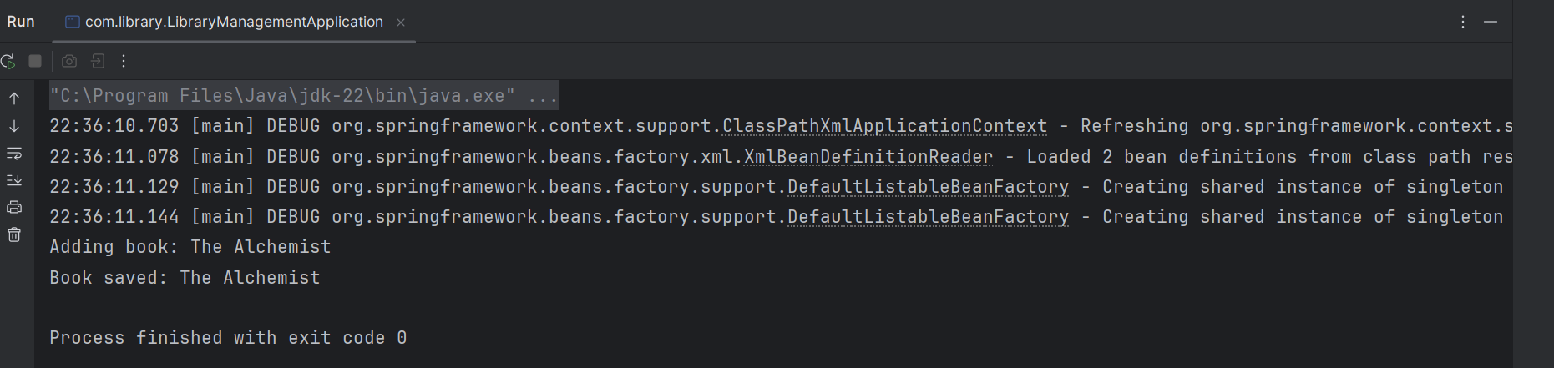

**Ques 2 : Implementing Dependency Injection.**

**Code :**

**--applicationContext.xml**

<?xml version="1.0" encoding="UTF-8"?>  
<beans xmlns="http://www.springframework.org/schema/beans"  
 xmlns:xsi="http://www.w3.org/2001/XMLSchema-instance"  
 xsi:schemaLocation="http://www.springframework.org/schema/beans  
 https://www.springframework.org/schema/beans/spring-beans.xsd">  
  
 <bean id="bookRepository" class="com.library.repository.BookRepository"/>  
  
 <bean id="bookService" class="com.library.service.BookService">  
 <property name="bookRepository" ref="bookRepository"/>  
 </bean>  
  
</beans>

**--BookService.java**

package com.library.service;  
  
import com.library.repository.BookRepository;  
  
public class BookService {  
  
 private BookRepository bookRepository;  
  
 // Setter Injection  
 public void setBookRepository(BookRepository bookRepository) {  
 this.bookRepository = bookRepository;  
 }  
  
 public void addBook(String bookName) {  
 System.*out*.println("Adding book: " + bookName);  
 bookRepository.save(bookName);  
 }  
}

**--BookRepository.java**

package com.library.repository;  
  
public class BookRepository {  
 public void save(String bookName) {  
 System.*out*.println("Book saved: " + bookName);  
 }  
}

**Output :**

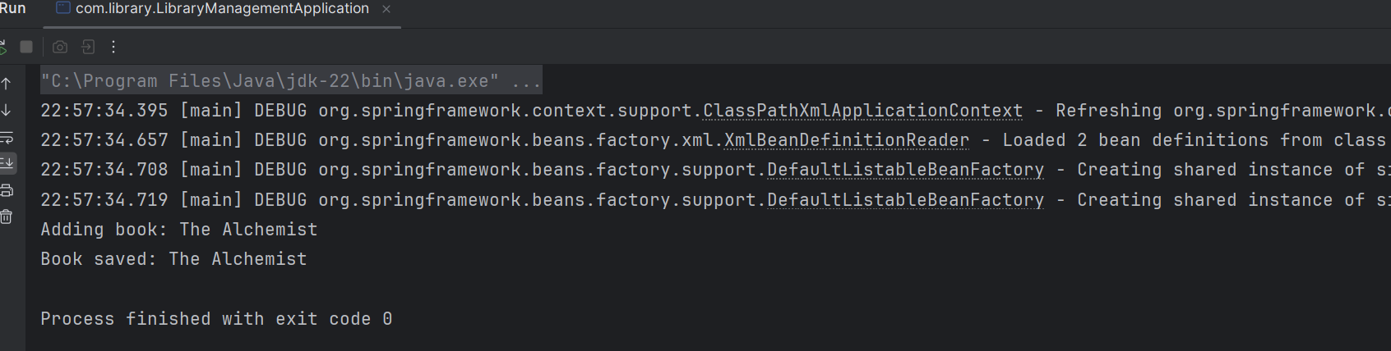

**Ques 3 : Creating and Configuring a Maven Project**

**Code :**

**--pom.xml**

<project xmlns="http://maven.apache.org/POM/4.0.0"  
 xmlns:xsi="http://www.w3.org/2001/XMLSchema-instance"  
 xsi:schemaLocation="http://maven.apache.org/POM/4.0.0 http://maven.apache.org/xsd/maven-4.0.0.xsd">  
 <modelVersion>4.0.0</modelVersion>  
  
 <groupId>com.library</groupId>  
 <artifactId>LibraryManagement</artifactId>  
 <version>1.0-SNAPSHOT</version>  
  
 <properties>  
 <maven.compiler.source>1.8</maven.compiler.source>  
 <maven.compiler.target>1.8</maven.compiler.target>  
 <project.build.sourceEncoding>UTF-8</project.build.sourceEncoding>  
 </properties>  
  
 <dependencies>  
 <!-- Spring Core + Context -->  
 <dependency>  
 <groupId>org.springframework</groupId>  
 <artifactId>spring-context</artifactId>  
 <version>5.3.30</version>  
 </dependency>  
  
 <!-- Spring AOP -->  
 <dependency>  
 <groupId>org.springframework</groupId>  
 <artifactId>spring-aop</artifactId>  
 <version>5.3.30</version>  
 </dependency>  
 <!-- AspectJ (for annotations like @Aspect, @Before, etc.) -->  
 <dependency>  
 <groupId>org.aspectj</groupId>  
 <artifactId>aspectjweaver</artifactId>  
 <version>1.9.20.1</version>

</dependency>

<!-- Spring WebMVC -->  
 <dependency>  
 <groupId>org.springframework</groupId>  
 <artifactId>spring-webmvc</artifactId>  
 <version>5.3.30</version>  
 </dependency>  
  
 <!-- SLF4J & Logback (optional for logging) -->  
 <dependency>  
 <groupId>org.slf4j</groupId>  
 <artifactId>slf4j-api</artifactId>  
 <version>1.7.36</version>  
 </dependency>  
 <dependency>  
 <groupId>ch.qos.logback</groupId>  
 <artifactId>logback-classic</artifactId>  
 <version>1.2.11</version>  
 </dependency>  
 </dependencies>  
  
 <build>  
 <plugins>  
 <!-- Compiler Plugin -->  
 <plugin>  
 <groupId>org.apache.maven.plugins</groupId>  
 <artifactId>maven-compiler-plugin</artifactId>  
 <version>3.10.1</version>  
 <configuration>  
 <source>1.8</source>  
 <target>1.8</target>  
 </configuration>  
 </plugin>  
 </plugins>  
 </build>  
</project>

**--applicationContext.xml**

<beans xmlns="http://www.springframework.org/schema/beans"  
 xmlns:xsi="http://www.w3.org/2001/XMLSchema-instance"  
 xmlns:aop="http://www.springframework.org/schema/aop"  
 xsi:schemaLocation="  
 http://www.springframework.org/schema/beans  
 https://www.springframework.org/schema/beans/spring-beans.xsd  
 http://www.springframework.org/schema/aop  
 https://www.springframework.org/schema/aop/spring-aop.xsd">  
  
 <bean id="bookRepository" class="com.library.repository.BookRepository"/>  
  
 <bean id="bookService" class="com.library.service.BookService">  
 <property name="bookRepository" ref="bookRepository"/>  
 </bean>  
  
 <aop:aspectj-autoproxy />  
</beans>

**--LoggingAspect.java**

package com.library.aop;  
  
import org.aspectj.lang.JoinPoint;  
import org.aspectj.lang.annotation.Aspect;  
import org.aspectj.lang.annotation.Before;  
import org.springframework.stereotype.Component;  
  
@Aspect  
@Component  
public class LoggingAspect {  
  
 @Before("execution(* com.library.service.*.*(..))")  
 public void logBefore(JoinPoint joinPoint) {  
 System.*out*.println("🔍 Executing: " + joinPoint.getSignature().getName());  
 }  
}

**--LibraryController.java**

package com.library.controller;  
  
import org.springframework.stereotype.Controller;  
import org.springframework.web.bind.annotation.GetMapping;  
import org.springframework.web.bind.annotation.ResponseBody;  
  
@Controller  
public class LibraryController {  
  
 @GetMapping("/hello")  
 @ResponseBody  
 public String sayHello() {  
 return "Hello from LibraryController!";  
 }  
}

**--BookRepository.java**

package com.library.repository;  
  
public class BookRepository {  
 public void save(String bookName) {  
 System.*out*.println("Book saved: " + bookName);  
 }  
}

**--BookService.java**

package com.library.service;  
  
import com.library.repository.BookRepository;  
  
public class BookService {  
 private BookRepository bookRepository;  
  
 // Setter for DI  
 public void setBookRepository(BookRepository bookRepository) {  
 this.bookRepository = bookRepository;  
 }  
  
 public void addBook(String bookName) {  
 System.*out*.println("Adding book: " + bookName);  
 bookRepository.save(bookName);  
 }  
}

**--LibraryManagementApplication.java**

package com.library;  
  
import com.library.service.BookService;  
import org.springframework.context.ApplicationContext;  
import org.springframework.context.support.ClassPathXmlApplicationContext;  
  
public class LibraryManagementApplication {  
 public static void main(String[] args) {  
 // Load Spring context from XML  
 ApplicationContext context = new ClassPathXmlApplicationContext("applicationContext.xml");  
  
 // Get the BookService bean  
 BookService bookService = context.getBean("bookService", BookService.class);  
  
 // Call a method to test dependency injection  
 bookService.addBook("The Alchemist");  
 }  
}

**Output :**

